Real World Application Sample
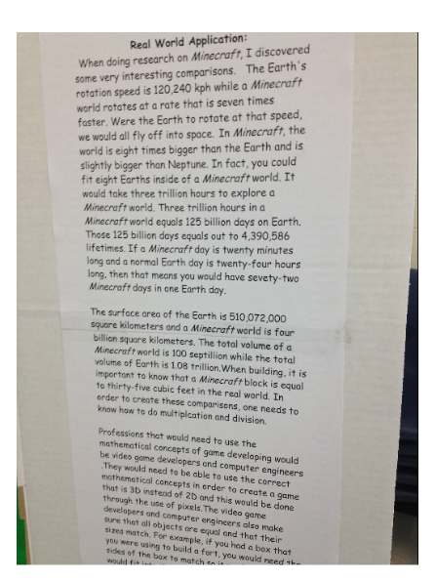
The information in this writing shows how the mathematics concepts are connected to the real world topic that was chosen by the student. The writing should explain what the student has discovered about how math is used/applied in the topic. It should state specific math concepts that are the focus for the project and how they are connected to the profession, idea, sport, toy/game, etc. that they student chose for the project. It also gives examples of other professions that would use these math concepts and how they would be used in each profession.

