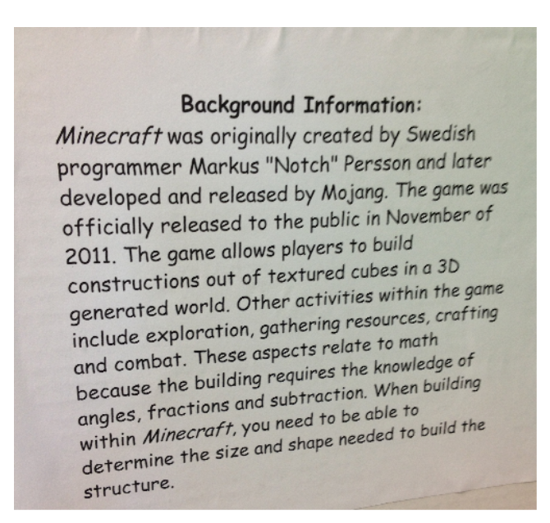
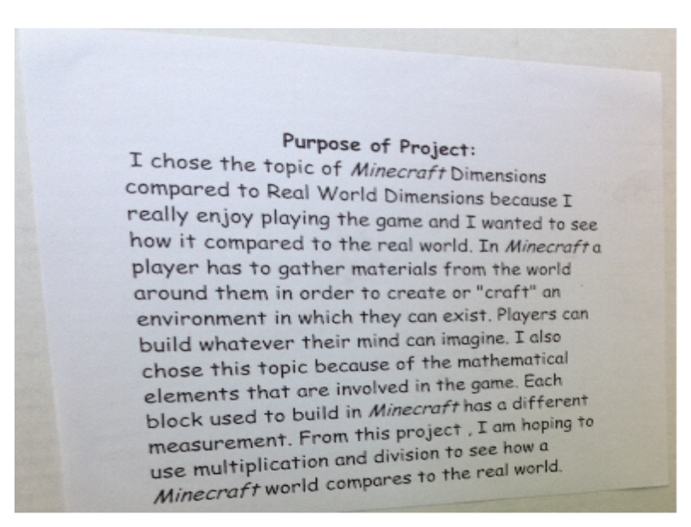
Math Fair
Below are samples of the Purpose and Background information for the project. Both components are due typed by January 5, 2016.

